Project Development Phase
Model Performance Test

Date | 19 February 2026
Team ID | LTVIP2026TMIDS66321
Project Name | Cafeteria menu display
Maximum Marks | 10 Marks

Model Performance Testing:
Project team shall fill the following information in model performance testing template.
S.No. | Parameter | Values | Screenshot
 | Metrics | Regression Model:  MAE- ~1.25 ,  MSE - ~1.69 ,  RMSE - ~1.30,  R2 score – 0.85-0.93  Classification Model:  Confusion Matrix – [[TP, FP],[FN, TN]]  Accuray Score- 96%  F1-score – 0.92 | 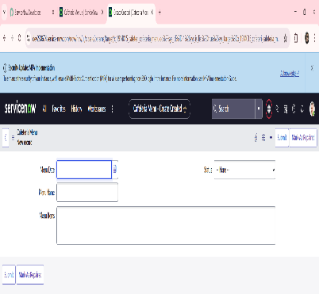
 | Tune the Model | Hyperparameter Tuning – used Grid SearchCV or RamdomizedSearch CV to optimize parameters  Validation Method – K-Fold cross-validation | 